

**Customer Requirements Specifications (CRS)**

***Production Module***

# **Document Information**

|  |  |
| --- | --- |
| Document Name | CRS of Procurement Management for Samuda Chemicals Ltd. |
| Document Author | Kamrun Nahar |
| Document Version | 1.0 |
| Release Date |  |

|  |  |
| --- | --- |
| Review by | Md. Mahfuzur Rahman |
| Review Date | TBA |
| Approved By | Matiar Rahman |
| Approval Date | TBA |

Signed on behalf of Signed on behalf of

Samuda Chemicals Ltd. Genweb2 Limited

Name: Name:

Designation: Designation:

Date: Date:

**______________________________ ______________________________**

Signature Signature

# **Document History**

|  |  |  |  |  |  |
| --- | --- | --- | --- | --- | --- |
| A=Added, M=Modified, D=Delete | | | | | |
| **Version No** | **Date** | **Section No** | **A/M/D** | **Description of Change** | **Author** |
| 1.0 | 29-Jan-2017 |  | A | Initial | Kamrun Nahar |
|  |  |  |  |  |  |
|  |  |  |  |  |  |

Contents

**A.** **Document Information** 2

**B.** **Document History** 3

**1.0** **Introduction** 5

**1.1 Purpose of CRS** 5

**2.0** **Production Module Overview** 5

**3.0** **Features of Production Module** 6

**4.0 Feature Description of Production Module** 6

**4.1** **Consumption** 6

**4.2** **Finished Goods** 6

**5.0 Appendix** 7

**6.0 To be Determined** 14

# **Introduction**

# **1.1 Purpose of CRS**

The purposes of this CRS (Customer Requirement Specification) are to clearly identify the customer requirements and provide a detailed document. The customer will review the document and approve/make changes as required. It will also help the review team to validate whether the customer requirements have been fulfilled or not.

# **Production Module Overview**

The Production record in any manufacturing ERP system performs the changing of stock quantities decrementing raw materials and incrementing assemblies or finished goods and any associated accounting. This module will allow entering into the production how many of a particular raw materials user want to produce and system will split serial numbered items down to separate lines for each product.

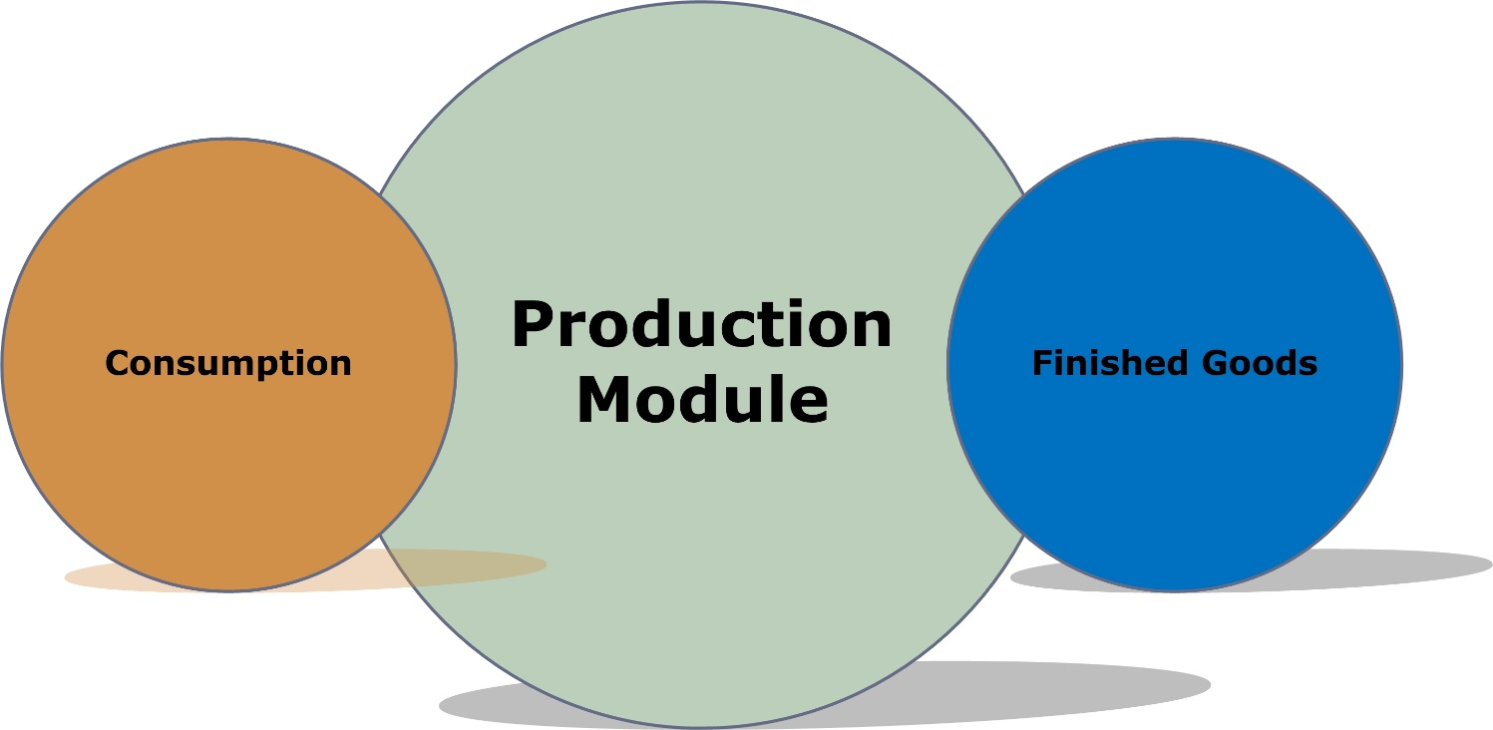

**Fig:** Production Module

**Why Samuda Needs Production Module**

* It minimizes the inventory, cuts down lead the time required for production, cuts down the production cycle duration and help to minimize the lead time required for automation and subcontracting.
* Production/manufacturing processes are completed using only essential materials. This prevents manufacturing waste.
* It reduces errors during subsequent production stages which minimizes the duration of the production cycle.
* Automation is a built-in feature for almost all process-based manufacturing software. Integration of every manufacturing process reduces human error.

# **Features of Production Module**

The following features will be covered by production module:

1. Consumption
2. Finished Goods

# **4.0 Feature Description of Production Module**

## **Consumption**

The process in which the substance of a thing is completely destroyed, used up, or incorporated or transformed into something else. Consumption of goods is the amount of raw material used in a particular time period. E.g. A Company will produce 2000 Personal Computer (PC). To assemble the Personal Computer (PC) it needs keyboard, mouse etc. So this system will allow to take input of 200 consumption of keyboard, mouse etc. for producing a new product. This system will help user to prepare some analytical report for better business.

## **Finished Goods**

The products in a manufacturer's inventory that are completed and are awaiting to be sold. This account as containing the cost of the products in the finished goods warehouse. A manufacturer must disclose in its financial statements the amount of finished goods, work-in-process, and raw materials input as well. This is the last stage for the processing of goods

The module will help users by tracking number of finished goods at manufacturers’ end which are not yet sold or distributed to the end-user. This system will help user to prepare some analytical report for finished goods.

# **5.0 Appendix**

Some Forms of Samuda maintains for its production system.

1.

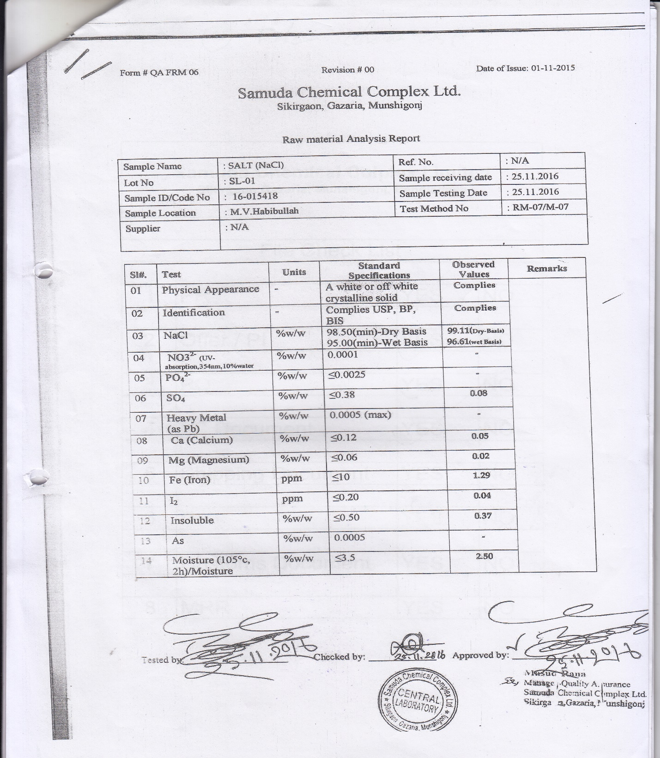

2.

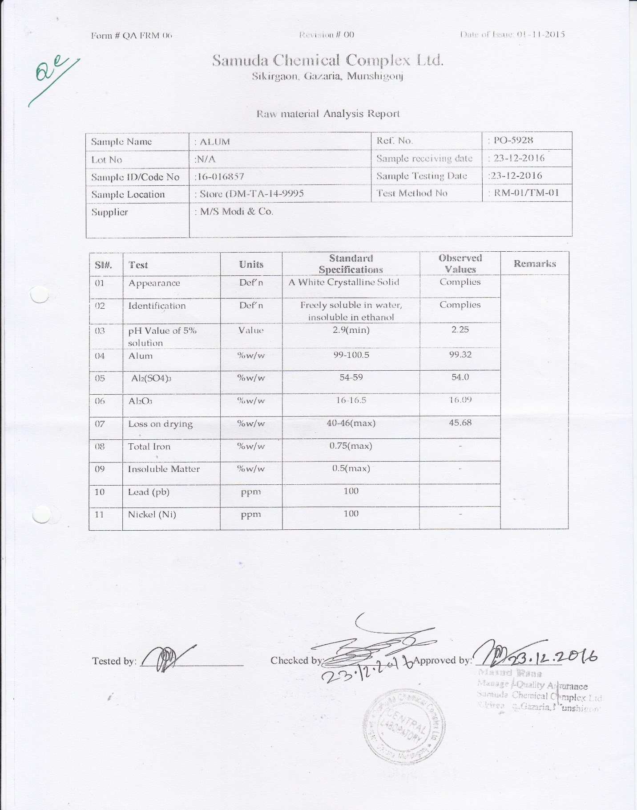

3.

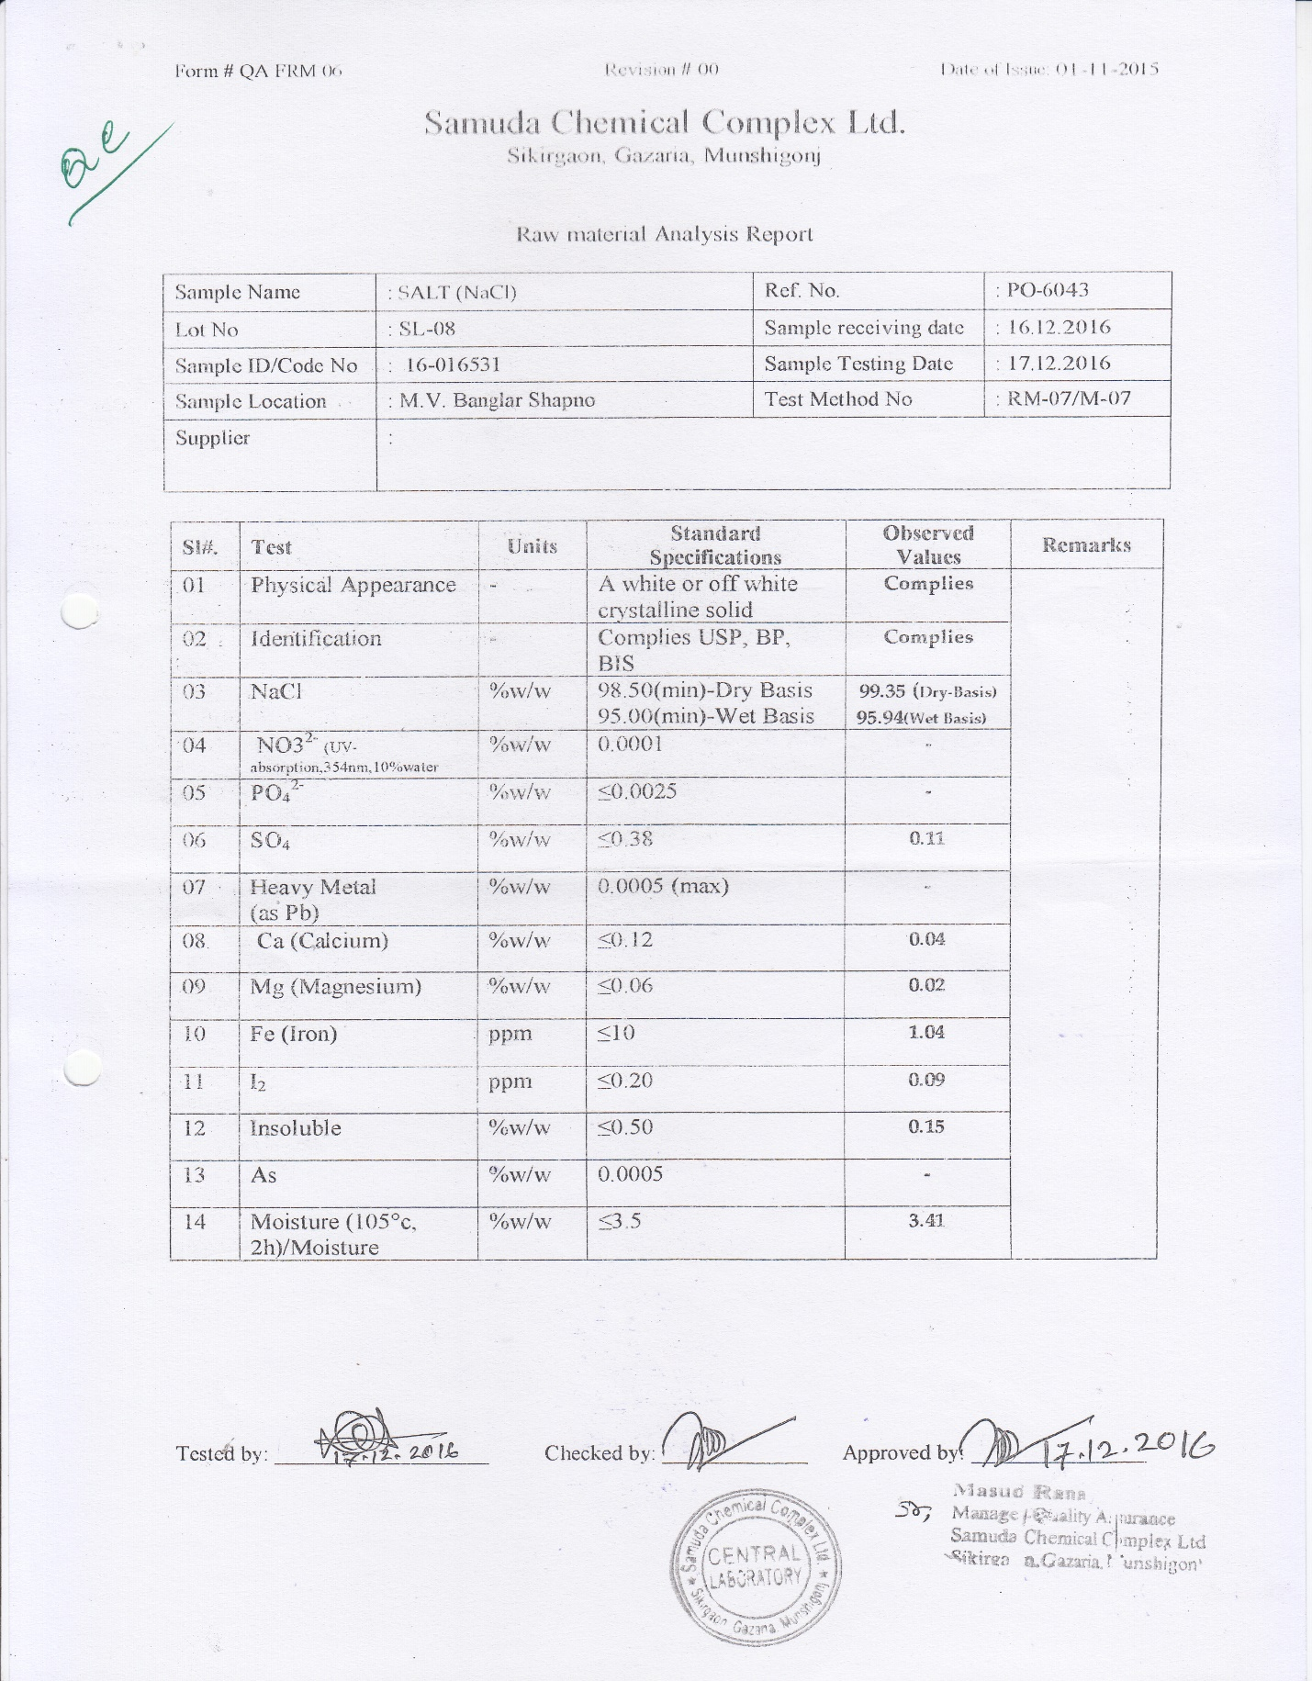

4.

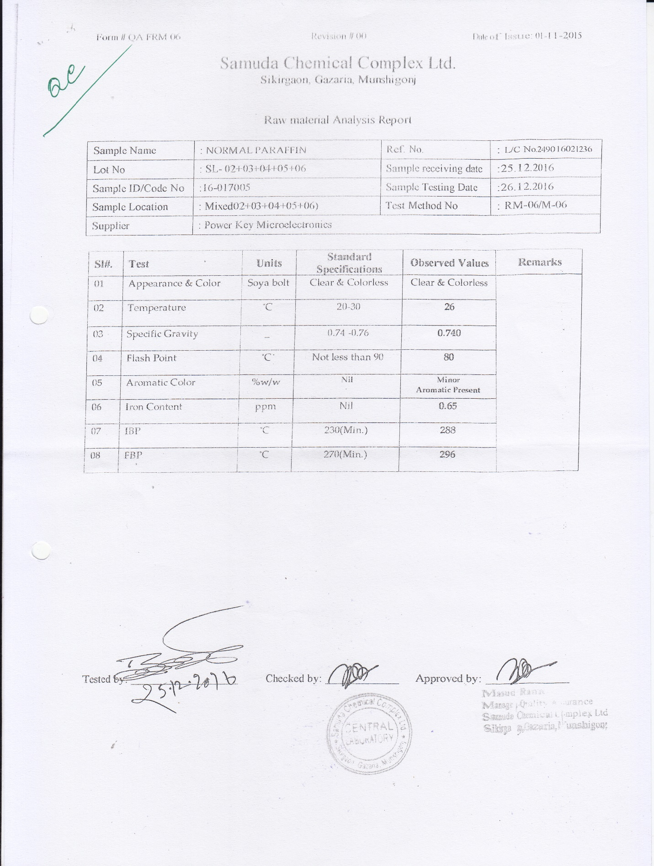

5.

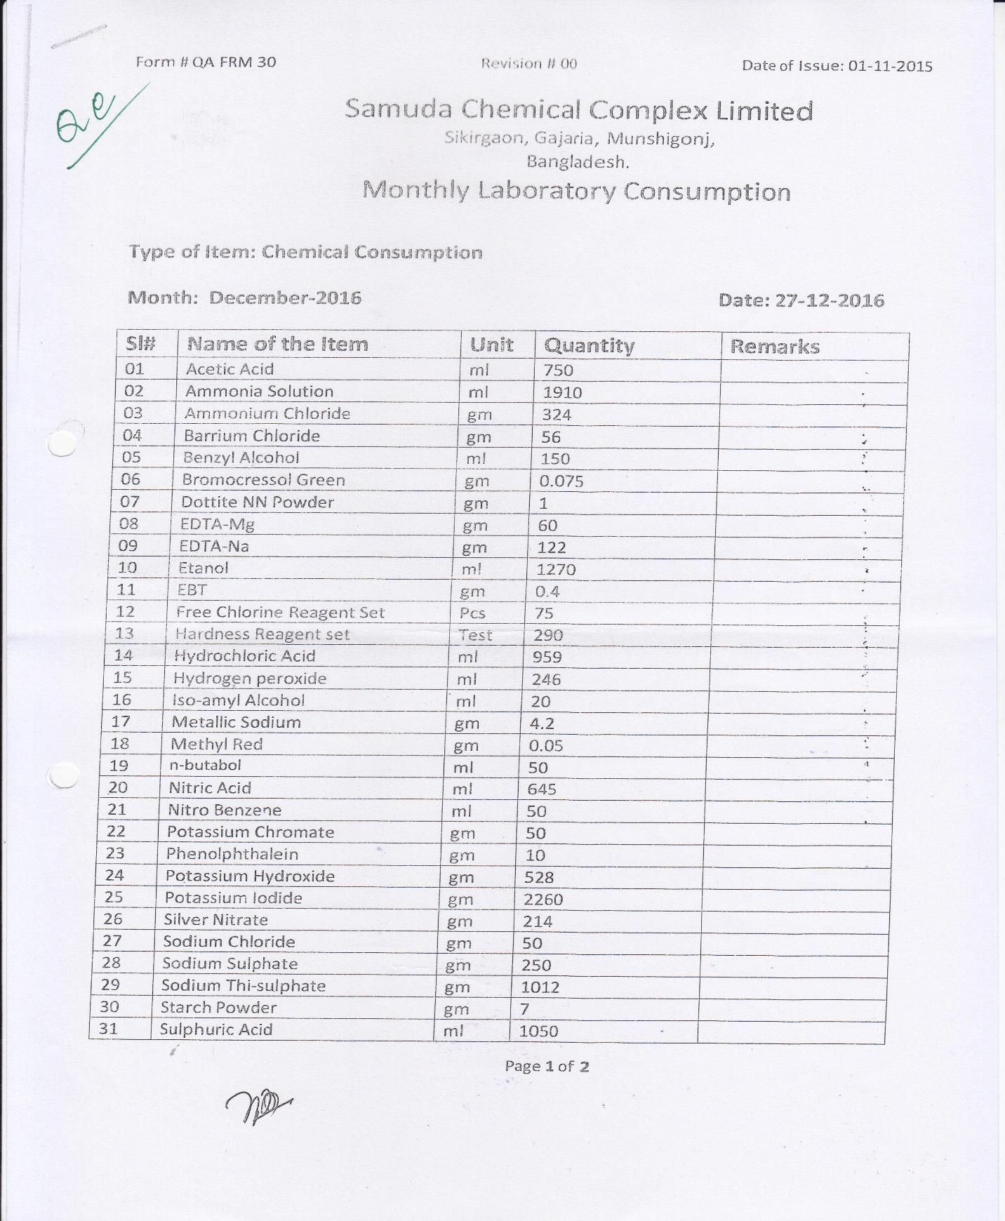

6.

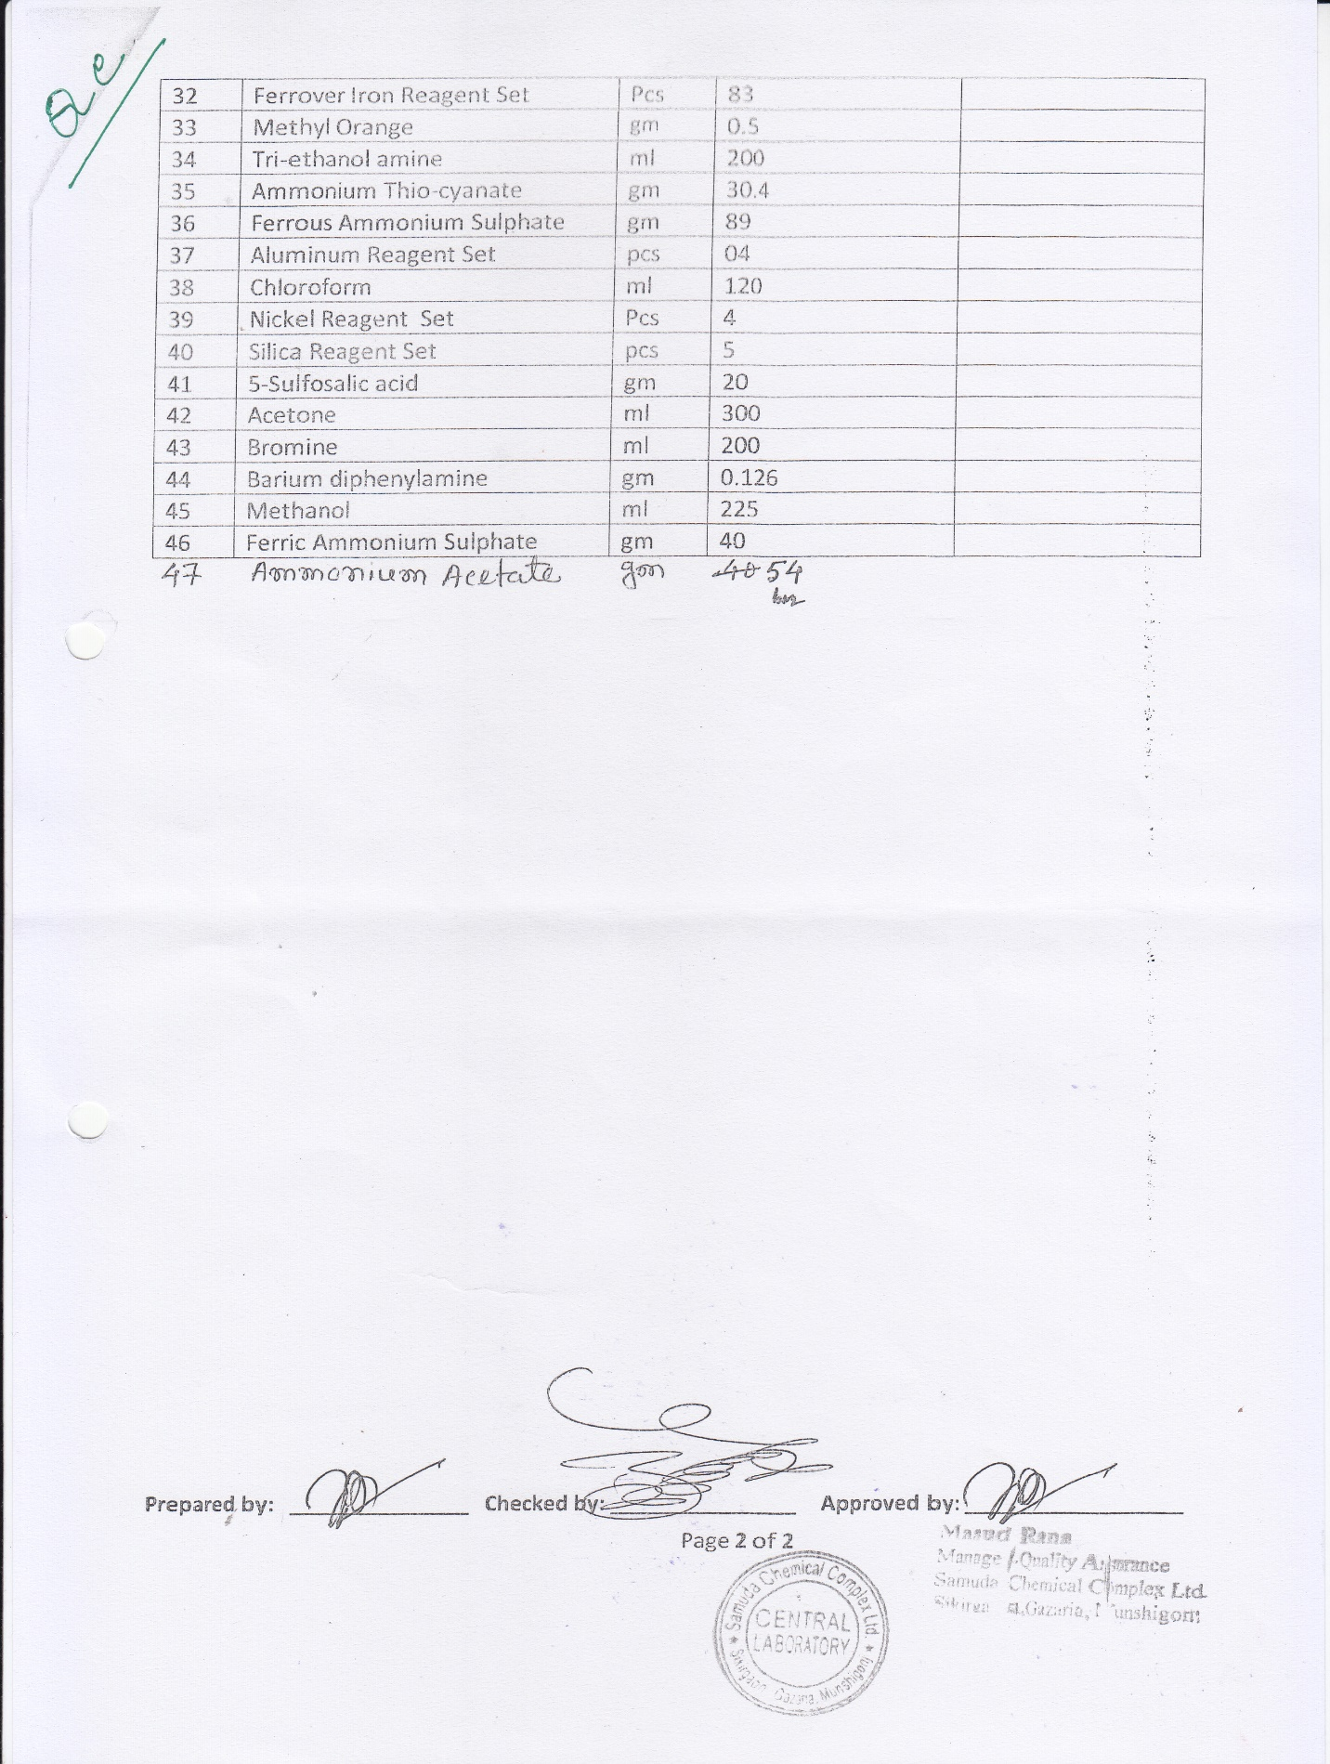

# **6.0 To be Determined**

1. ISO 9001 related reports are not implemented within this phase. We will cover in next phase.

Signed on behalf of Signed on behalf of

Samuda Chemicals Ltd. Genweb2 Limited

Name: Name:

Designation: Designation:

Date: Date:

**______________________________ ______________________________**

Signature Signature